Experiment-11
Name: -J pranitha Regno: -192472073
Course Code: -MLA0305 Slot-B

Title
Policy Gradient Implementation using REINFORCE Algorithm

Aim
To implement the REINFORCE policy gradient algorithm using TensorFlow and Keras and train an agent to learn an effective policy in the CartPole environment.

Procedure
- Initialize the CartPole-v1 environment using Gymnasium.
- Define a neural network with TensorFlow and Keras to represent the policy.
- Use a softmax output layer to obtain the probability of selecting each action.
- Initialize the policy network and optimizer.
- Start an episode and observe the current state.
- Select an action according to the probabilities produced by the policy network.
- Execute the action and record the resulting reward and next state.
- Continue until the episode terminates.
- Calculate the discounted return for each step of the episode.
- Compute the policy loss using the REINFORCE policy-gradient rule.
- Calculate the gradients of the policy loss and update the network weights.
- Repeat the process for multiple episodes.
- Record the reward, policy loss, entropy, action probabilities, and episode length.
- Plot the learning progress, policy loss, entropy, action probabilities, and episode length.
- Prepare a summary table and save the complete training results as a CSV file.

Code
!pip -q install gymnasium tensorflow

import numpy as np import pandas as pd import matplotlib.pyplot as plt import gymnasium as gym import tensorflow as tf from tensorflow.keras import Sequential from tensorflow.keras.layers import Input,Dense from tensorflow.keras.optimizers import Adam

np.random.seed(42) tf.random.set_seed(42)

print("="*70) print("EXPERIMENT 11") print("Policy Gradient Implementation using REINFORCE Algorithm") print("="*70)

env=gym.make("CartPole-v1")

state_size=4 action_size=2 episodes=150 gamma=0.99 learning_rate=0.001

model=Sequential([
Input(shape=(state_size,)),
Dense(64,activation="relu"),
Dense(64,activation="relu"),
Dense(action_size,activation="softmax")
])

optimizer=Adam(learning_rate=learning_rate)

def select_action(state):
state=np.array([state],dtype=np.float32) probabilities=model(state,training=False).numpy()[0] action=np.random.choice(action_size,p=probabilities) return action,probabilities
def calculate_returns(rewards):
returns=[] total=0

for reward in reversed(rewards): total=reward+gamma*total returns.insert(0,total)

returns=np.array(returns,dtype=np.float32)

if len(returns)>1:
returns=(returns-np.mean(returns))/(np.std(returns)+1e-8)

return returns

reward_history=[] loss_history=[] entropy_history=[] length_history=[] action0_history=[] action1_history=[]

for episode in range(episodes):

state,_=env.reset()

states=[] actions=[] rewards=[] probabilities=[]

done=False

while not done:

action,probs=select_action(state)

next_state,reward,terminated,truncated,_=env.step(action) done=terminated or truncated
states.append(state) actions.append(action) rewards.append(reward) probabilities.append(probs)

state=next_state

returns=calculate_returns(rewards)

states_tensor=tf.convert_to_tensor( np.array(states), dtype=tf.float32
)

actions_tensor=tf.convert_to_tensor( np.array(actions), dtype=tf.int32
) returns_tensor=tf.convert_to_tensor(
returns, dtype=tf.float32
)

with tf.GradientTape() as tape:

action_probs=model(
states_tensor, training=True
)

selected_probs=tf.gather( action_probs, actions_tensor, axis=1, batch_dims=1
)

log_probs=tf.math.log( selected_probs+1e-8 )
policy_loss=-tf.reduce_mean( log_probs*returns_tensor
)

entropy=-tf.reduce_mean( tf.reduce_sum( action_probs*tf.math.log( action_probs+1e-8
), axis=1
)
)

total_loss=policy_loss-0.01*entropy

gradients=tape.gradient(
total_loss, model.trainable_variables
)
optimizer.apply_gradients(
zip( gradients, model.trainable_variables
)
)

avg_probs=np.mean(
probabilities, axis=0
)

reward_history.append( np.sum(rewards)
)

loss_history.append( float(policy_loss.numpy())
)
entropy_history.append( float(entropy.numpy())
)

length_history.append( len(rewards)
)

action0_history.append( avg_probs[0]
)

action1_history.append( avg_probs[1]
)

if (episode+1)%25==0:
print(
"Episode:", episode+1,
"| Reward:", round(reward_history[-1],2), print("\n") print("="*70) print("CONCLUSION") print("="*70)

print(
"The REINFORCE policy gradient algorithm was successfully"
)

print(
"implemented using TensorFlow and Keras."
)

print(
"The policy directly learned action probabilities from"
)

print(
"complete episode rewards."
)
print(
"The learning curve, policy loss, entropy, action"
)

print(
"probabilities and episode length were analyzed."
)

print(
"The final reward was compared with the initial reward"
)

print(
"to evaluate the learning performance."
)

print("\nGenerated Files:") print("REINFORCE_Full_Dataset.csv") print("REINFORCE_Summary.csv") print("\nExperiment 11 Completed Successfully.")

Visualization

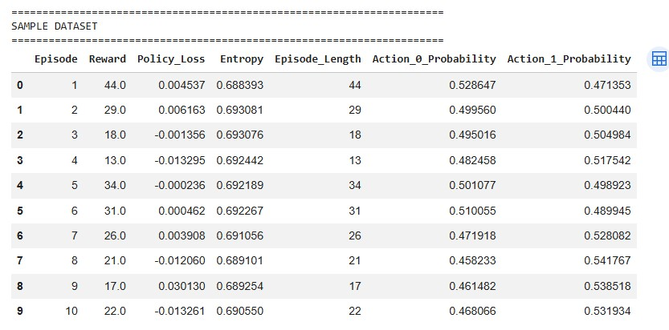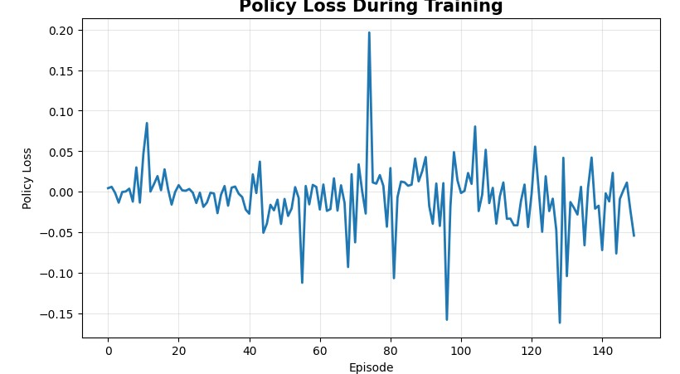
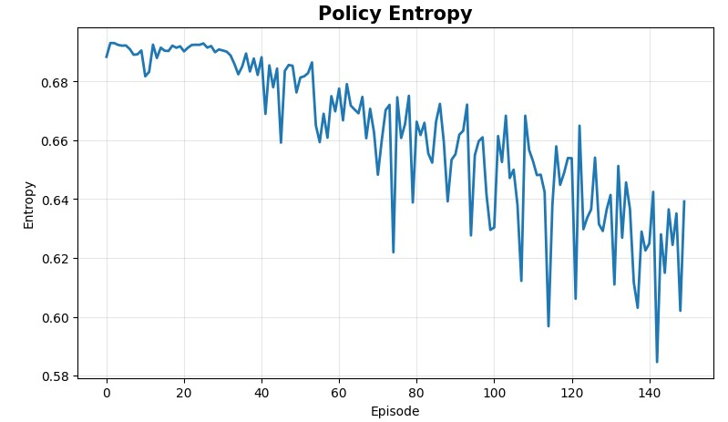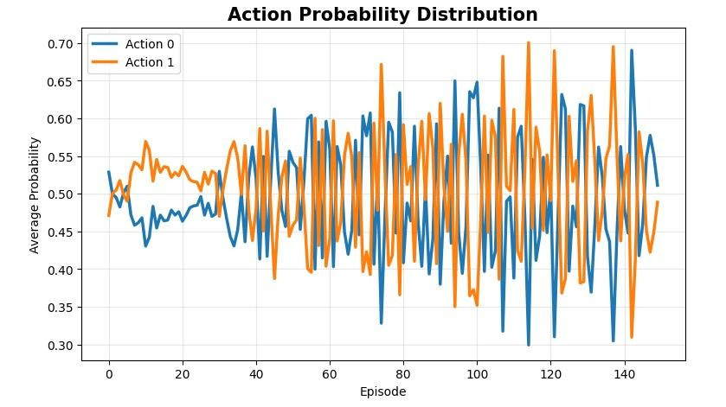
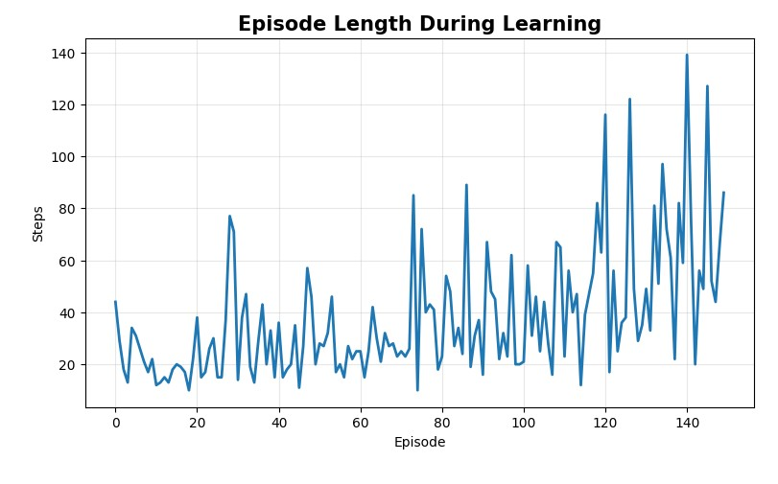

Summary Table

Parameter | Result
Algorithm | REINFORCE
Environment | CartPole-v1
Episodes | 150
Final Average Reward | Obtained from program
Maximum Reward | Obtained from program
Reward Variance | Obtained from program
Average Episode Length | Obtained from program

Result
The REINFORCE policy gradient algorithm was successfully implemented using TensorFlow and Keras. The agent learned an action-selection policy directly from episode rewards. The learning curve, policy loss, entropy, action probabilities, and episode length were analyzed to observe the learning behavior and performance of the policy.

